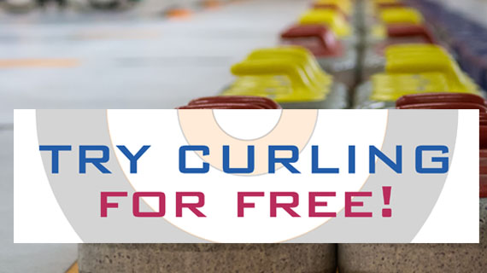
If you’re interested in trying the fun Olympic sport of curling, now’s your chance!

The Cornwall Curling Club would like to help you take that first step – for FREE, with no obligation!!

You’re invited to take part in our Open House, Registration, and free Adult Curling School
- Tuesday, October 13
- Wednesday, October 14
- Thursday, October 15
6:30 to 8:30 each evening. Come one, two, or all three nights – there will be instruction at varying levels each night.
Dress in warm clothes with loose or stretchy pants and bring clean indoor shoes. Arrive at least 15 minutes prior to start time to ensure you are registered and ready to go. The evening instruction is intended for adults only – younger curlers receive training as part of their ongoing program.

We’ll also tell you why curling is such a great sport, and why you should join our Club! We emphasize the social and recreational aspects of curling, but we have provincial champions, too!
Whether you’re a brand new curler, or have years of experience, the Cornwall Curling Club has a spot for you!
We offer daytime curling, as well as evening single entry and league curling starting Oct. 19, along with fun weekend bonspiels in a social atmosphere.
For more info, visit CornwallCurling.com, email info@cornwallcurling.com or call (902) 566-4427.

See you on the ice!!

